Contents

I. What is Anime? 2

A. Definition: 2

B. Artistic Styles: 2

C. Diverse Genres: 2

II. Origins and History 2

Early Roots: 2

Post-WWII Development: 3

Global Expansion: 3

III. Impact and Popularity 3

A. Cultural Influence: 3

B. Dedicated Fanbase: 3

C. Cross-Cultural Exchange: 3

IV.The Big Three Anime 3

A:One Piece 4

B.Naruto 4

C.Bleatch 4

[1]

Anime[2] [1] is a captivating and diverse form of entertainment that encompasses a wide array of genres and themes. It has gained immense popularity worldwide, attracting a dedicated fanbase and influencing various aspects of popular culture. In the following sections, we will delve into the realm of anime, discussing its definition, artistic styles, diverse genres, origins, history, and its impact on society.

# I. What is Anime? [1]

## A. Definition:

Anime refers to animated works of art that are often originated in Japan but are now produced globally.

## B. Artistic Styles:

Anime showcases a distinctive art style characterized by large, expressive eyes, vibrant colors, and diverse character designs.

## C. Diverse Genres:

Anime spans across a broad range of genres including action, adventure, romance, horror, and fantasy, catering to a diverse audience.

# II. Origins and History

## Early Roots:

Anime can be traced back to its origins in Japan during the early 20th century, drawing inspiration from both domestic and Western animation.

## Post-WWII Development:

The post-World War II era witnessed a significant surge in anime production, contributing to its growth and evolution.

## Global Expansion:

In the late 20th century, anime gained international recognition and popularity, with iconic series such as "Astro Boy" and "Akira" paving the way.

# III. Impact and Popularity

## A. Cultural Influence:

Anime has had a profound influence on various aspects of popular culture, including fashion, music, and even technology.

## B. Dedicated Fanbase:

Anime has cultivated a passionate and dedicated fanbase that actively supports the industry through conventions, merchandise, and online communities.

## C. Cross-Cultural Exchange:

The global popularity of anime has facilitated cross-cultural exchange, fostering an appreciation for Japanese culture and storytelling worldwide.

Anime's ability to captivate audiences with its diverse narratives, unique art styles, and broad range of genres has solidified its place as a prominent form of entertainment in the modern world. Whether it be through its compelling stories, visually stunning animation, or its cultural impact, anime continues to leave an indelible mark on the global stage.

# IV.The Big Three Anime

The term "Big Three" in the world of anime refers to a triumvirate of immensely popular and influential anime series that dominated the mid-2000s to early 2010s. These three series are Naruto, One Piece, and Bleach. Each of them carved a lasting legacy in the anime and manga industry, captivating audiences with their unique stories, well-developed characters, and epic battles. "Naruto," created by Masashi Kishimoto, [2] follows the journey of Naruto Uzumaki, a young ninja with dreams of becoming the strongest ninja and the leader of his village. Eiichiro Oda's [2] "One Piece" revolves around Monkey D. Luffy's quest to find the legendary One Piece treasure and become the Pirate King, leading a diverse crew of pirates. Tite Kubo's "Bleach" centers on Ichigo Kurosaki, a teenager with the ability to see ghosts who becomes a Soul Reaper and defends the living world from evil spirits. The Big Three left an indelible mark on the anime community, attracting a massive fanbase worldwide and contributing significantly to the global popularity of anime during their heyday.

Big three are in trending[3]

## A:One Piece

"One Piece" is a highly popular and long-running Japanese manga and anime series created by Eiichiro Oda [3]. The story follows Monkey D. Luffy, a young and adventurous pirate with the ability to stretch his body like rubber after eating a Devil Fruit. Luffy sets out on a grand journey to find the ultimate treasure known as "One Piece" and become the Pirate King. Along the way, he assembles a diverse crew of loyal and powerful individuals, each with their own unique abilities and dreams. The series is known for its rich world-building, complex characters, epic battles, and themes of friendship, freedom, and the pursuit of one's dreams. With a vast and intricate lore, "One Piece" has captured the hearts of fans worldwide and continues to be a source of excitement and wonder for both new and long-time followers of the series.

## B.Naruto

"Naruto" is a beloved and iconic Japanese manga and anime series created by Masashi Kishimoto [2]. The story revolves around Naruto Uzumaki, a young ninja with dreams of becoming the strongest ninja and earning the respect of his fellow villagers in the Hidden Leaf Village. However, Naruto carries a dark secret: he is the host of the Nine-Tails Fox, a powerful and destructive tailed beast. The series follows Naruto's journey as he faces numerous challenges, makes lasting friendships, and strives to protect his village. With its compelling characters, intricate world-building, and themes of perseverance, friendship, and the pursuit of one's dreams, "Naruto" has captured the hearts of fans worldwide and remains a significant part of anime and manga culture.

## C.Bleatch

"Bleach" is a popular Japanese manga and anime series created by Tite Kubo. [4] The story revolves around Ichigo Kurosaki, a high school student with the ability to see ghosts. His life takes a dramatic turn when he accidentally acquires the powers of a Soul Reaper, a celestial being responsible for guiding the souls of the deceased to the afterlife and protecting the living from evil spirits known as Hollows. Ichigo's newfound responsibilities lead him to confront various supernatural threats, including powerful foes, complex moral dilemmas, and a secret society of Soul Reapers. With its compelling characters, intense battles, and a captivating exploration of life, death, and the afterlife, "Bleach" has gained a massive following and remains a significant part of anime and manga culture.

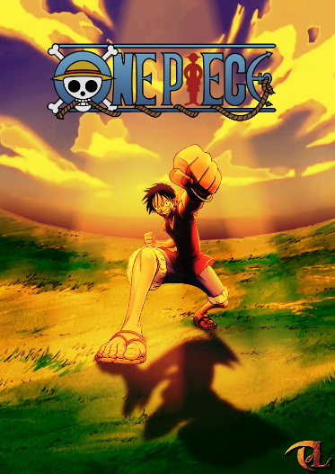

Figure 1

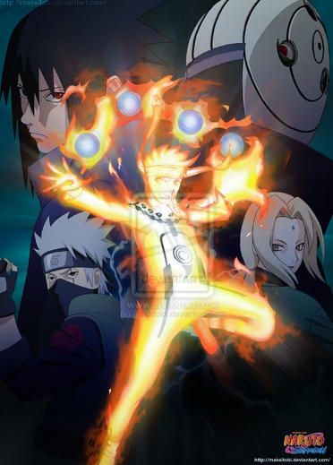

Figure 2

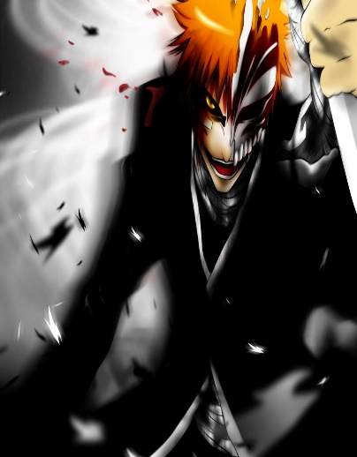

Figure 3

1. |  |  |
   | --- | --- |
   | [1] | "Anime," *Anime,* 1956. |
   | [2] | Masashi Kishimoto, "Masashi Kishimoto,," *Naruto.* |
   | [3] | Oda, "Anime," 1999. |
   | [4] | T. Kubo, "Tite Kubo," *Tite Kubo,* 1999. |

  
2. Anime is all age programe
3. Big three is in trending